One Church One Day Reflection June 2023

Despite it being half term, at least 47 of us united in prayer for a full 24 hours at the weekend. The theme for OCOD this month is Psalm 27:4. I had asked Peter to read this wonderful Psalm at Prayer & Praise Together, and felt a strong desire to share a meditation on Psalm 27. However, I had searched my meditation books, Google, and YouTube, couldn’t find anything appropriate, and didn’t have time to write one. Just as I gave up, a text came through from Sally Swann, asking if I had time for a call. I spoke with Sally. Sally wanted to share a meditation on Psalm 27! Praise the Lord! Our Lord who provides. Please take a moment to rest, breathe slowly, and enjoy.
Psalm 27
You are my Source, my Way, my Home.
In You I rest secure.
In You I gather strength.
In You I begin to see.

When fear arises
From within or from without
I remember
Who You are
And how I am
In You.

Oh that I may dwell in You
day by day, moment by moment.
Then peace would be mine.
Then I could persevere
when the waters threaten to overwhelm.
Then my eyes would be filled with beauty
and my mouth with song.
Then courage and wisdom
Would carry me to safe shores.

This I know:
You are.
In You,
I am.

Your goodness is seen
In the land of the living.
All who turn to You,
turn towards Home.
Sometimes the Lord asks us to rest and receive, and sometimes to do and give. Our Mission Focus for June is the orphanage in India. Following their prayer time, one person felt called to give to the children of the orphanage, enquiring how much a uniform costs in response to Prasant’s prayer requests. What a blessing.
Graham shares a wonderful description of time spent at Prayer & Praise and then in the following hour of prayer:

Just wanted to say that I do really appreciate the time spent together and then afterwards. It is a tonic and refreshes my soul and Claire’s.

It was lovely last night to pray for individuals. That also motivates me. And takes my eyes to Jesus, well at least off myself!!!!!!!!!!

Ku was given a powerful Word and picture in his midnight encounter with the Lord:
A busy Saturday awaits me, so I’m sending this through while it’s fresh. I wrote out the verse from Psalm 27 as I prayed (see attached) and as I wrote the pictures that came to heart and mind, and informed my writing were:
A flame - not of consuming but of a beacon. There to be followed and to guide, but needing to be carried by willing folk too.
A stick - seeing ourselves as a part of creation that might seem commonplace but is unique, has story, has the potential for growth, the potential to be energy, the potential to be different things to different people
The need to be these things - flame carriers, energy sticks, God-seekers not only in our own place, however warm we might get there, but taking the flame out, caring for it, letting other people see it that they too might follow it home.
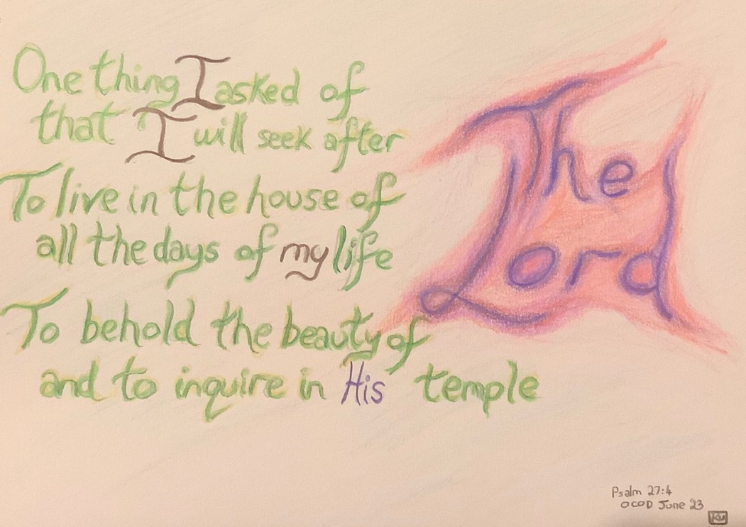
Gary experienced the Lord’s embrace in a 6am prayer walk, surrounded by the sights and sounds of creation:
I went for my usual 6am prayer walk, and this morning it was really sunny. As I walked, I prayed for people and situations and for the church and the 7 areas of priority. As I walked along the river and through the woods, I was reminded of God's wonderful creation and prayed for our rivers which are in need of greater protection. Birds were singing and I was reminded of the song 'Morning has Broken' and its wonderful lyrics:
Mine is the sunlight, mine is the morning
Born of the one light, Eden saw play
Praise with elation, praise every morning
God's recreation of the new day

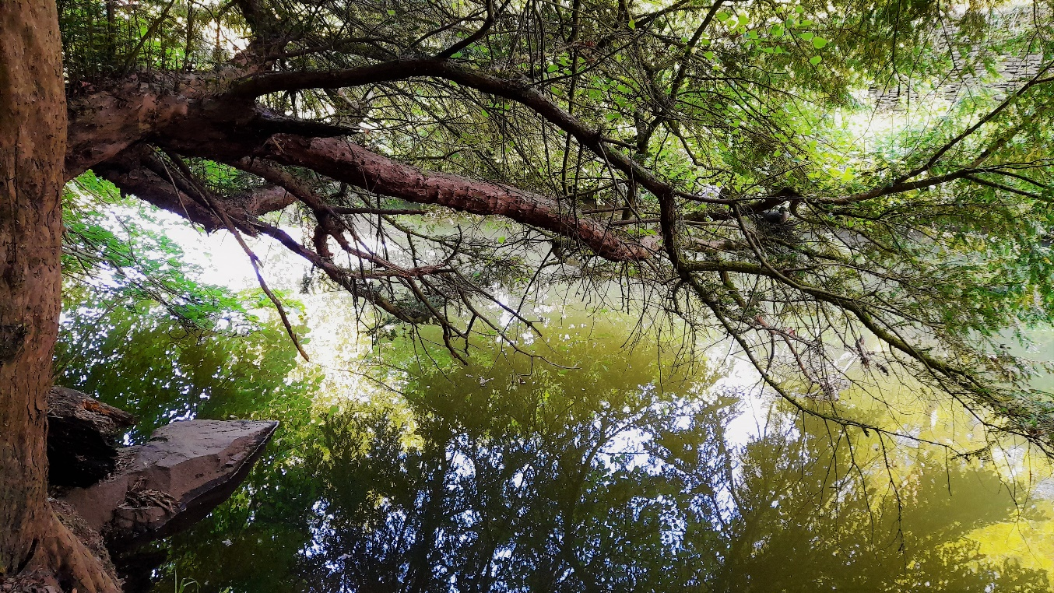
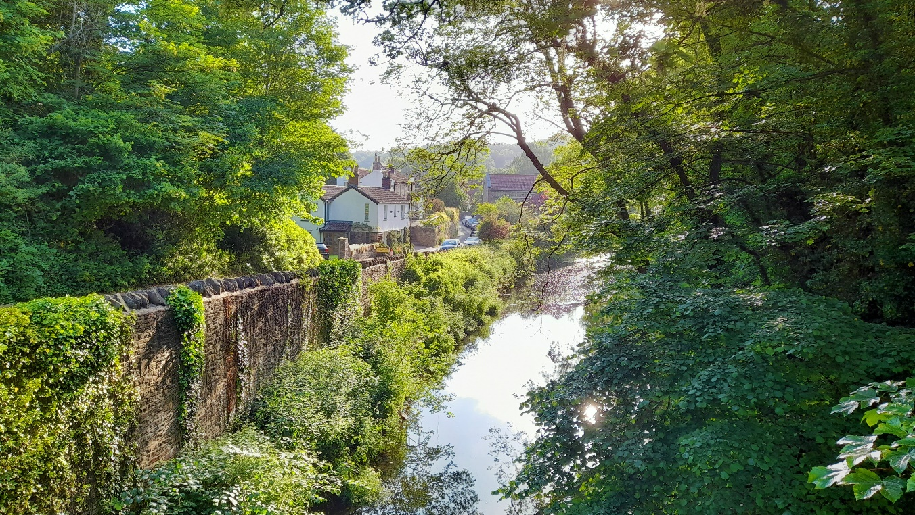

When considering Church vision/priorities, Ken spoke of ‘keeping in step with the Spirit’. ‘What are we inviting people in to? Is it solid: Bible based, God loving and full of love?’
Likewise, as I (Diane) prayed through Psalm 27 and our Church vision/priorities, I made lots of notes on love. In short - before we reach out, make healthy relationships, serve and bless people, we must love them. Before people will listen/open their door, they must be/feel loved. When we say we want to offer an expression of Church for all, how inclusive are we? What does it look like to be a loving, accepting, inclusive people? I considered the various places I’ve seen this kind of love. To love is to have the compassion of Christ. To love is to have the integrity of Christ. It’s most difficult to love those who are not like me/us. Ignorance. Need understanding, gained through the lens of love, the filter of love. The cross stands above it all.
There ends our reflections for OCOD this month. Words from the Lord, a picture, photos, a meditation, a song and a call to give. Please continue to pray into the Church vision/priorities and share with Dan or any member of the staff team. The songs below, Way Maker from Jerusalem, and Spirit Lead Me, both shared at Prayer & Praise, may help to guide us in our prayers.
With love and prayers
Diane x
https://www.youtube.com/watch?v=HhbtVCI67pw

https://www.youtube.com/watch?v=ABWnLjXer10

