One Church One Day Reflections
How wonderful that on our fourth annivesary of One Church One Day, around 50 of us gathered to pray, united with different churches across Bristol, and with thousands of people from all over the world in the World Day of Prayer.
As 17 of us gathererd for Prayer & Praise, we prayed for all that was on our hearts, for Palestine, the theme of WDP, and for our Mission Focus, Open Doors, and for those who have suffered and are suffering from knife crime. We were led in sung worship by a global choir singing a Palestinian worship song, ‘God of Peace,’ and students from Christian Unions all over the world singing ‘When I Survey.’
As I write these reflections, churches across Bristol, united by OCOD almost three years ago, are holding a Day of Prayer. Also the news of another fatal stabbing has just been confirmed. Please let’s continue to persevere in prayer. As we fix our eyes on him, may we see his kingdom come.
We woke the morning of OCOD to the surprise of snowy scenes. Our OCOD scripture was Mark 1:12 ‘The Spirit then compelled Jesus to go into the wilderness…’ Well for Gary’s early morning prayer hour, the Spirit compelled him to go out into the snow! Where he took this beautiful photo of his footprints in the fresh crisp snow.
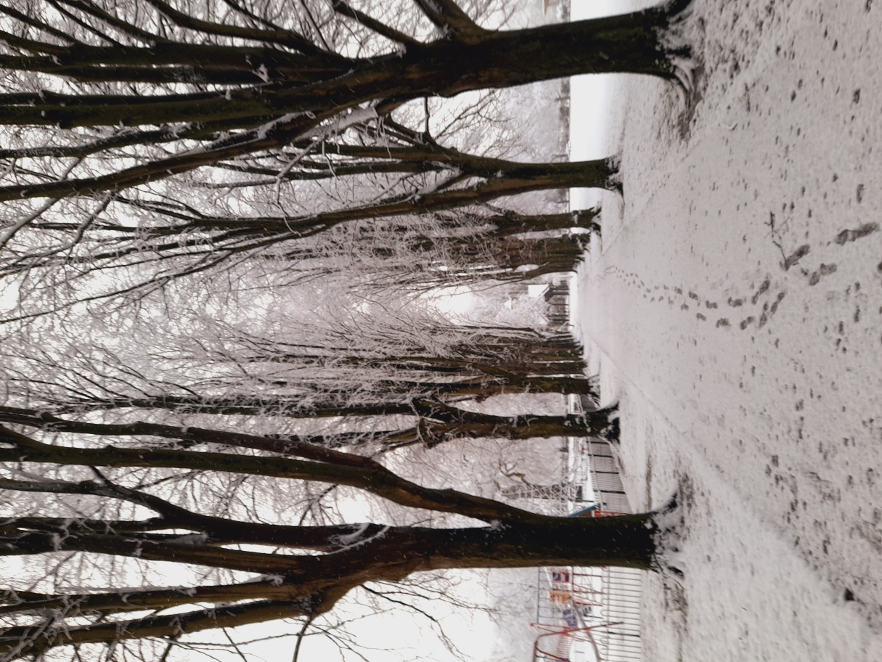
Mavis shared the following beautiful reflection…
6am. Sat. Early morning, praying for Mothers and children, after hearing which senior school they have been allocated. My grandson had his 2nd choice. Known to me Mothers and children in tears because they did not get what they wanted.
8-9.am. One church one day. Waking up to snow on the ground. It was quiet and peaceful. Reminded me of ‘Footprints’ in the sand. but this was Footprints in the snow.
Mark 1 v12. Sometimes we are stopped in our tracks. To listen to God’s voice, by waiting with patience, facing the challenges of the day. By “His” grace standing firm.

Luke shared what the Lord had placed on his heart in his time of prayer…

During the day before my hour of prayer I contacted Prasant, the man who runs Haven Home's day-to-day operations, to find out if there's any things I could pray for them specifically during my hour. Prasant responded within minutes to ask for prayers for the children who are taking exams at Haven Home, of which there are currently three: Maheswari, Anitha, and Prasant's son Ronnie. Later on in the month four more children will also begin their exams: Dhaneswari, Vyshali, Chendu, and Manikanta. These exams are equivalent to GCSEs and so are very important for the children's development.

As I often do during my prayer hour, I dedicated most of it to Haven Home and the wonderful various ministries they provide in their region. My hour slots are often in the very early hours of the morning and so I'm very conscious that as I'm praying their day is just beginning.

Yesterday morning I woke up to a message from Prasant with an update on how the exams were going - which so far are going very well. Having seen how hard all the children work during our visits to the orphanage we really pray that they get the results they so deserve. Had it not been for the awesome Haven Home ministry these children would have likely never been given the opportunity to have an education, and seeing them flourish and go onto achieve great things after they graduate from school is a real encouragement and a testament to the incredible provision of God. Everyone at Haven Home really appreciates the prayers of our congregation at Christ Church; so please keep praying for them! When we pray God listens, and God does incredible things.

For me, I swapped my usual 3am slot, for the safety of my patients, as I was working the next day, to the 3pm Soaking in Scripture. I got a hot chocolate and a blanket on our snowy day and snuggled up with the Lord. I enjoyed it so much that I continued into the next hour soaking in scripture, but this time I whipped the hoover round with the Lord, and then took a leaf out of Barbara’s book and played worship songs on the piano, not nearly as well as Barbara would have done!

Different ages, different congregations, those who can’t make it to a church building, those who worship in different church buildings, uniting for 24 hours in prayer, praying in different ways, but all to the same God who lavishes his love upon us.
Looking forward in sharing in this time together again next month.
Shalom, Diane x

