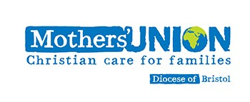Mothers’ Union Bristol Treasurer from 2025
An exciting opportunity has occurred for a person with experience and confidence in keeping financial records and accounting. Ideally this would suit an up and coming or recently retired accountant or finance officer, or someone already involved in managing accounts of a charity. Preferably someone with an interest in Mothers’ Union or in sympathy with our aims and mission.
From January 2025 Mothers’ Union will be merging with 7 other Dioceses in the South West to become Mothers Union South West. This body will have an appointed Treasurer who will oversee the accounts of all 8 Dioceses, so the Bristol Treasurer will need to be able to work closely with this new development and be open and flexible to change and new ways of working.
Additionally, we have plans in place to introduce the payment of Subscriptions by Direct Debit at the start of 2025. Members will be able to opt in to this, so some members will continue to pay via their Branch Treasurer, so it will be essential to be able to keep close records of these.
Currently Financial reports need to be presented at Trustee Meetings (approx. 5 per year) and at the two members days held in Spring (AGM) and Autumn. End of Year Statement of Accounts will need to be presented for Charity Commission report annually, but this will change as we enter the new arrangements.
Applicants now would have an opportunity to work alongside our current treasurer during the course of this year.
For more information about this valuable voluntary role with an organisation making a difference in our communities and around the world please contact:
jacky.mubristoldiocese@gmail.com
07501670265

